

VU University Medical Center Amsterdam
presents

3rd Practical Course on 3D/4D Ultrasound in Obstetrics & Gynaecology
in cooperation with Medison Europe BV

It is our pleasure to announce our 3rd training course on how to improve your skills in 3D/4D ultrasound

Thursday, 13th Dec. 2007
Friday, 14th Dec. 2007
Saturday morning, 15th Dec. 2007
Get the exact images you want.
Make the most of your ultrasound system.
Capture the secrets of 3D/4D ultrasound with equal emphasis on Obstetrics and Gynaecology techniques.
Don´t miss out on this opportunity to exchange information and skills with other OB/GYN doctors from the world.
Lectures will be accompanied by extensive demonstrations, hands-on training and offline analysis.
For exciting, knowledge-building 2½ days in Amsterdam, please contact Ms. Chongmee Lee for registration and more information.
chongmee@medison.com

registration fee is EUR 500, excluding flight & hotel including coffee/tea breaks, two lunches and first day dinner
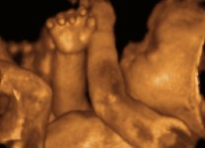

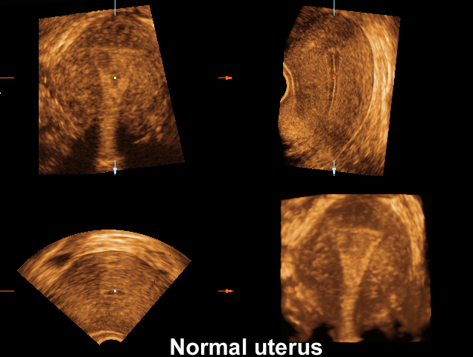
VU University Medical Center
De Boelelaan 1118, 1007 MB Amsterdam, the Netherlands
Vrije Universiteit medisch centrum
Verloskunde & Gynaecologie

